
JIMMA INSTITUTE OF TECHNOLOGY
FACULTY OF COMPUTING AND INFORMATICS
DEPARTMENT OF INFORMATION SCIENCE
Final Year Project-1(INSC 4712)
Automated Internship Management System
Group Members ID NO.
- Elham Gugsa…………………………… RU0695/15
- Ermias Mesfin……………………………RU0739/15
- Ezra Eshetu………………………………RU0775/15
- Fiyameta Sintayehu………………………RU0856/15
- Surafel Markos………………..…………RU1949/15

Mr Wosenu M : _____________________
Mr Solomon A : _____________________

Submitted to Faculty of Computing and Informatics, Jimma Institute of Technology,
Jimma University, in Partial fulfillment of the requirement of the Degree of Bachelor of Science in Information Science

Jimma

Approval Sheet
The project entitled “Automated Internship Management System” has been read and approved as fulfilling the requirements of the Department of Information Science, in partial fulfillment for the award of the Degree of Bachelor of Science in Information Science, Jimma University, Ethiopia.
Project and Scholarly Communication Management Team Leader
Advisor Name: Mr. Wosenu M
Signature: ____________________
Date: ____________________
Advisor Name: Mr. Solomon A
Signature: ____________________
Date: ____________________
Examiner I __________________Signature: ________________ Date: __________________
Examiner II _________________ Signature: _________________ Date: __________________
Examiner III _________________ Signature: _________________Date: _________________

ACKNOWLEDGEMENT
We would like to express our sincere gratitude to all those who contributed to the successful completion of this final year project. First and foremost, we thank Almighty God for granting us the strength, patience, and wisdom throughout this endeavor. Our heartfelt appreciation goes to our project advisors, Mr. Wesenu and Mr. Solomon , for their continuous guidance, valuable suggestions, constructive feedback, and encouragement at every stage, which played a vital role in shaping this work. We are also grateful to Jimma University and the Faculty of Computing and Informatics for providing the necessary academic knowledge, resources, and institutional support that made this project possible. We extend our thanks to our friends and classmates for their cooperation, insightful discussions, and moral support throughout the project period. Finally, we thank our family for their constant encouragement, understanding, and motivation, which inspired us to see this project to its completion.

Table of Contents
ACKNOWLEDGEMENT i
List Of Figuers iv
List Of Tables v
Abstract vi
Abbreviation vii
CHAPTER ONE 1
INTRODUCTION 1
1.1 Background Of The Project 1
1.2 Motivation 2
1.3 Existing System Study 2
1.3.1 Description of the Existing System 2
1.3.2 Statement Of The Problem 3
1.4 Objectives 3
1.4.1 General Objective 3
1.4.2 Specific Objectives 3
1.5 Feasibility Analysis 4
1.5.1 Operational Feasibility 4
1.5.3 Behavioral/Political Feasibility 4
1.5.4 Market Feasibility 5
1.5.5 Schedule Feasibility 5
1.5.6 Economic Feasibility 6
1.6 Scope Of Work 8
1.7 Significance 8
1.8 Target Beneficiaries 9
1.9 Methodology 9
1.9.1 Data Source and Preprocessing 10
1.9.1.1 Data Source 10
1.9.2 Data Preprocessing 10
1.9.3 Data Cleaning 10
1.9.4 Data Transformation 11
1.9.5 Data Integration 11
1.9.6 Fact-Finding Techniques 11
1.9.7 System Analysis and Design 12
1.9.8 Development Tools 12
1.9.9 Model Training and Evaluation 14
System-Level Evaluation 14
1.9.10 Implementation Approach 14
1.10 Limitations of the Project 15
1.11 Risks, Assumptions, and Constraints 15
1.12 Team Composition 16
CHAPTER TWO 17
REQUIREMENT ANALYSIS AND SPECIFICATION 17
2.1 Introduction of Existing System 17
2.2 Business Rules. 19
2.3 Proposed System 21
2.3.1 Proposed System Description 21
2.4 System Requirements 22
2.4.1 Functional Requirements 22
2.4.2 Non-Functional Requirements 23
2.5 System Analysis 25
2.5.1 System Requirements Specification (SRS) 25
CHAPTER THREE 44
SYSTEM DESIGN 44
3.1 Introduction 44
3.2 Proposed System 44
3.3 Design Goals 45
3.4 Deployment Diagram 46
3.5 Architectural Design 47
3.5.1 Subsystem Decomposition 48
3.5.2 Component Diagram 48
3.5.3 Deployment Diagram 49
3.5.4 Persistent Modeling 50
3.5.5 Access Control and Security 50
3.5.6 Global Software Control 50
3.5.7 Boundary Conditions 51
3.5.8 Machine Learning Model Design 51
3.6 User Interface Design 51
3.7 Database Design 54
3.9 Summary 58
REFERENCE 59

List Of Figuers

Figure 1 Use case model diagram 27
Figure 2 Sequence diagram for Student Registration 34
Figure 3 Sequence diagram Apply for internship 35
Figure 4 Sequence Diagram for Attendance 35
Figure 5 Weekly Report Evaluation 36
Figure 6 State chart diagram of Internship Application 36
Figure 7 State Chart of Attendance Process 37
Figure 8 State chart of weekly report status 38
Figure 9 Activity Diagram of Internship Application 39
Figure 10 Activity Diagram of Attendance 40
Figure 11 Activity diagram for Weekly Reporting 40
Figure 12 class diagram 41
Figure 13 Main flow 42
Figure 14 Student flow 42
Figure 15 Supervisor flow 43
Figure 16 University Administrator 43
Figure 17 Company Admin 43
Figure 18 Deployment Diagram 46
Figure 19 Architectural Design 47
Figure 20 Subsytem Decomposition 48
Figure 21 Component Diagram 49
Figure 22 Deployment diagram 2 49
Figure 23 Landing page 51
Figure 24 Login Page 52
Figure 25 Register Page 52
Figure 26 Student Page 52
Figure 27 University Admin 53
Figure 28 Company Admin 53
Figure 29 Supervisor page 53
Figure 30 ER DIAGRAM 54

List Of Tables
Table 1 Project Timeline 6
Table 2 Cost Breakdown 7
Table 3 Development Tools 13
Table 4 Team Composition 16
Table 5 use case description for login 28
Table 6 use case description for Register 29
Table 7 use case description for Apply for Internship 30
Table 8 Approve/Reject Application 31
Table 9 Mark Attendance 32
Table 10 Weekly Report Submission & Evaluation 33
Table 11 Users Table 55
Table 12 Students 55
Table 13 Organization 55
Table 14 Internship_Post 55
Table 15 Applications 56
Table 16 Supervisor_Assignment 56
Table 17 Attendance 56
Table 18 Weekly_Report 57
Table 19 AI_Evaluation 57
Table 20 Supervisor_Evaluation 57

Abstract
This project introduces the Automated Internship Management System a web-based platform designed to revolutionize internship tracking and performance management for higher education institutions. The system addresses traditional inefficiencies, such as manual attendance sheets and subjective evaluations, using Artificial Intelligence (AI) for face recognition, Natural Language Processing (NLP) for report analysis, and GPS verification for attendance. Students register, apply for internships, and record attendance remotely, while supervisors and administrators oversee the process via interactive dashboards. Manual attendance forms, supervisor reviews, and weekly progress assessment are automated to ensure transparency, accountability, and data-driven decision-making. Core modules include AI-based facial recognition for attendance, GPS location verification, report scoring using NLP, organization registration, supervisor dashboards, and a comprehensive admin backend. The solution leverages open-source technologies including Django, React, MySQL, OpenCV, and TensorFlow. This system streamlines the internship lifecycle, reduces administrative burden, and promotes fair and efficient internship evaluation, preparing students for real-world challenges in a digital environment.
Keywords: Face Recognition, GPS Tracking, Internship Management, Django, AI, Performance
Evaluation, MySQL.

Abbreviation
AI | Artificial Intelligence
API | Application Programming Interface
CRUD | Create, Read, Update, Delete
CSS | Cascading Style Sheets
DB | Database
ERD | Entity Relationship Diagram
HTML | HyperText Markup Language
HTTP | HyperText Transfer Protocol
IDE | Integrated Development Environment
IT | Information Technology
JSON | JavaScript Object Notation
JS | JavaScript
MVC | Model View Controller
OOP | Object-Oriented Programming
PHP | Hypertext Preprocessor
SQL | Structured Query Language
UI | User Interface
UX | User Experience

CHAPTER ONE

INTRODUCTION

Background Of The Project
Internship programs play a crucial role in bridging the gap between academic learning and real-world professional experience. They enable students to apply theoretical knowledge, develop practical skills, and gain exposure to professional organizational environments. Despite their importance, the management of internship programs remains a significant challenge for universities and host organizations. Many institutions still depend on manual attendance sheets, paper-based evaluations, and periodic written reports, which are time-consuming, error-prone, and lack transparency (Nurfaizi & Hindarto, 2023).
A major challenge in internship supervision is the inability to reliably verify student attendance and genuine participation. Manual attendance recording methods are highly vulnerable to proxy attendance and manipulation. Similarly, weekly performance reports are often subjective and repetitive, making it difficult to assess interns fairly and accurately. These limitations reduce accountability and hinder effective monitoring by supervisors and university administrators (Manual Internship Systems in Educational Contexts, 2021).
To address these challenges, this project proposes a web-based Automated Internship Attendance and Performance Management System using Artificial Intelligence. The system integrates face recognition and GPS technologies for accurate attendance verification and applies Natural Language Processing (NLP) to analyze interns’ weekly reports objectively. Registration and access to the system are controlled through university administrator approval, with secure system-generated login credentials. Company administrators manage internship postings and supervisor assignments, while university administrators monitor activities centrally. This approach enhances transparency, efficiency, security, and data-driven decision-making in internship management.

Motivation
Effective internship management is essential for students’ professional development, yet many institutions still rely on manual and outdated processes. These methods result in inaccurate attendance tracking, subjective performance evaluation, and administrative inefficiency. This project is motivated by the need to apply AI technologies to create a transparent, reliable, and accountable internship management system for all stakeholders (Nurfaizi & Hindarto, 2023).

Existing System Study
    - Description of the Existing System
In many higher education institutions, the existing internship management system operates mainly through manual and semi-automated procedures. Internship application, attendance tracking, and performance evaluation are handled using handwritten attendance sheets, paper-based forms, and basic spreadsheet tools. Students are required to submit physical documents such as placement letters, attendance logs, and weekly reports to supervisors and university coordinators, which results in slow processing and data fragmentation.
Attendance is commonly recorded through manual sign-in sheets or supervisor signatures. According to Nurfaizi and Hindarto (2023), such traditional attendance methods are highly vulnerable to human error, proxy attendance, and data manipulation, making them unreliable for accurate internship monitoring. Similarly, studies on manual internship systems in educational Contexts Indicate That These Systems Generate Excessive Paperwork And Repetitive Administrative Tasks, Increasing Workload For Supervisors And University Staff (Manual Internship Systems In Educational Contexts, 2021).
Weekly Reports Are Typically Evaluated Subjectively Without Standardized Criteria, While Communication Among Students, Host Organizations, And Universities Relies On Emails Or Phone Calls. The Absence Of A Centralized Platform Limits Real-Time Monitoring, Reduces Transparency, And Makes Effective Supervision Difficult.

    - Statement Of The Problem
Internship management in many higher education institutions is still dominated by manual and semi-automated processes that compromise accuracy, accountability, and efficiency. Attendance recording methods such as handwritten logs are highly prone to human error, proxy attendance, and data manipulation. According to Nurfaizi and Hindarto (2023), traditional internship attendance systems lack reliable verification mechanisms, resulting in inaccurate records. In addition, performance evaluation often relies on subjective judgments and unstandardized weekly reports, leading to inconsistent grading and reduced transparency (Manual Internship Systems in Educational Contexts, 2021).
Furthermore, the absence of a centralized and automated internship management platform creates communication gaps among students, host organizations, and universities. Manual handling of records increases administrative workload and delays monitoring and reporting. Studies indicate that such fragmented systems weaken institutional oversight and efficiency, justifying the need for an automated and integrated internship management solution (Manual Internship Systems in Educational Contexts, 2021).

Objectives

General Objective
To develop a secure web-based AI-driven system that automates internship attendance tracking using face recognition and GPS verification while evaluating intern performance through NLP-based weekly report analysis.

Specific Objectives
- To design a web platform that allows students to apply for internships in registered organizations.
- To enable company administrators to review and approve or reject internship applications.
- To implement AI-based face recognition and GPS verification for reliable attendance tracking.
- To develop an NLP module for automated evaluation of interns’ weekly reports.
- To provide university administrators with real-time dashboards for monitoring and analysis and overall system performance.

Feasibility Analysis

Operational Feasibility
The system streamlines internship program management by replacing manual methods with automated digital processes. Attendance tracking, weekly report submission, and supervisor evaluations all move to a web portal, reducing paperwork and minimizing errors. Each user type (student, supervisor, administrator) has a dedicated dashboard for their tasks, resulting in a more organized workflow. Minimal training is needed due to the intuitive design, and in-built help features further support users. Automated notifications and reminders prevent missed attendance and deadlines, contributing to a smoother experience and increased compliance.
    - Technical Feasibility
Project development employs proven, open-source tools and frameworks, ensuring robust technical foundations and lower risk. Django is used for secure, scalable backend operations, while React enables responsive interface development. TensorFlow and OpenCV allow implementation of reliable AI models for face recognition and NLP analysis. MySQL handles large datasets efficiently, supporting rapid queries and safe data storage. The required hardware computers, webcams, and GPS-enabled devices is readily available and compatible with system components. The development team possesses the necessary expertise for integration and testing, extensive documentation is availablefor all selected technologies.
    - Behavioral/Political Feasibility
Success depends on stakeholder engagement and adherence to institutional policy. At the behavioral level, resistance is addressed by involving users in early system demonstrations and feedback sessions, building ownership and trust. Privacy and consent procedures follow both university rules and broader standards, especially for biometric and location data. The project upholds institutional objectives, supporting transparent recordkeeping and educational quality improvements. No political roadblocks exist; university leadership is likely to support technology that increases accountability and aligns with national digital strategies.

Market Feasibility
Digital internship management is gaining traction in academic and professional circles. Many institutions are actively seeking platforms that automate attendance and reporting, cut down administration, and offer data analytics. This system’s features AI attendance, GPS verification, dynamic dashboards are well-positioned to address these needs, making it attractive to universities and organizations alike. Scalability is built in; after successful deployment, the solution can easily be adopted in other faculties, departments, and peer institutions. The trend toward digital transformation in education supports future expansion.

Schedule Feasibility
The project plan divides work into clear stages: requirement analysis, system design, development, testing and evaluation, deployment, and documentation. Each stage has designated milestones and timelines, managed via weekly progress meetings. Using Django and React accelerates prototyping and reduces debugging time. The Waterfall model ensures sequential development and minimizes overlap. Sufficient time is allocated for data collection, AI model training, user testing, and final improvements, making project completion within 19–20 weeks realistic. Risk mitigation includes regular reviews and milestone checks.

NO | PHASE | DURATION |  |  |  | REMARK
 |  | (Oct 25 /2025 – Mar 7 2026)
1 | Project Title Approvals |  |  |  |  | Submit project title, , prepare requirement documentation.
2 | Requirement Analysis |  |  |  |  | Conduct interviews collect requirements; define core features finalize functional & non-functional requirement
3 | System Design |  |  |  |  | System architecture design , DFD, ERD, use case diagrams, UX/UI design, finalizing database schema, workflow diagrams
4 | Backend & AI Module Development |  |  |  |  | Implement backend logic, authentication, role management
5 | Frontend Development & Integration |  |  |  |  | Develop React frontend UI, connect REST APIs. And Integrate modules
6 | Testing, Documentation & Optimization |  |  |  |  | Conduct testing; resolve bugs; refine AI accuracy. Prepare user manuals, project documentation, testing reports; optimize system.
7 | Deployment, Training & Submission |  |  |  |  | Demo preparation, deployment setup, rehearsal. Final presentation, system submission, deliverables handover
 | TOTAL | 19 WEEKS
Table 1 Project Timeline

Economic Feasibility
The project is economically feasible because it primarily relies on open-source technologies such as Django, React, TensorFlow, OpenCV, and MySQL, which eliminates licensing expenses. The main project costs involve development effort, basic hardware needs, documentation, hosting, and system training. Since no specialized paid tools are required, the overall financial burden remains low compared to traditional systems.

Cost Benefit Analysis
The automated internship management system offers significant long-term advantages over the manual workflow. Automation minimizes repetitive paperwork, reduces supervisor workload, prevents attendance fraud, and improves reporting accuracy. The system’s centralized dashboard enhances productivity and enables more interns to be managed with fewer errors. This leads to time savings, improved transparency, and better institutional decision-making benefits that outweigh the initial development costs.

Cost of the Project
The overall project cost mainly covers development-related expenses, hosting, documentation, training, and testing activities. No recurring software licensing fees are required. The project also includes necessary contingency funds to handle unforeseen expenses during development and deployment.

Cost Breakdown.
Description | Case out | Estimated Cost (ETB)
Utilities | printing, and paper materials | 2,000
Development Tools & Software Resources | Includes AI libraries ,NLP tools, design software. Also includes internet/data | 10,000
Infrastructure Costs | Hosting setup and server configuration for deployment and testing | 5,000
Training & Documentation | User manuals, training sessions for supervisors and admins | 4,000
Awareness Campaign | Flyers, posters, and communication materials | 3,000
Testing & Maintenance | Testing activities and one-year maintenance support | 4,000
Contingency | Unplanned or emergency expenses | 2,000
Total |  | 30,000

Table 2 Cost Breakdown

Scope Of Work
The scope of this project covers the design and development of a web-based Automated Internship Management System that supports the core operational phases of the internship lifecycle, including internship application, placement, supervision, attendance monitoring, and performance evaluation. The system incorporates controlled user registration with university administrator approval, system-generated authentication credentials, internship application management, supervisor assignment, AI- and GPS-based attendance tracking, AI-driven performance evaluation, and centralized administrative monitoring.
The system serves four primary user roles: students, company administrators, supervisors, and university administrators. It operates through standard web browsers and requires an active internet connection. The primary focus of the system is to improve transparency, accountability, security, and efficiency in internship supervision and monitoring. Future enhancements may include mobile application integration and advanced analytical tools to support deeper performance assessment and decision-making.

Significance
The Automated Internship Management System provides significant benefits to students, organizations, and academic institutions. By digitizing and automating key processes such as attendance recording, performance evaluation, and reporting, the system reduces administrative workload while improving accuracy and accountability. AI-based attendance verification using face recognition and GPS minimizes fraud and ensures reliable records.
The integration of NLP-based performance analysis promotes objective and consistent evaluation of interns, reducing bias commonly associated with manual assessments. Real-time dashboards and analytical reports enable timely decision-making and effective oversight by university administrators. Overall, the system strengthens trust, transparency, and fairness in internship programs while positioning the institution as a leader in applying AI-driven solutions to academic management.

Target Beneficiaries
The Automated Internship Management System is designed to serve a broad range of users who are critical to successful internship programs within the academic and professional landscape:
- Students: Gain direct access to internship applications, streamlined digital attendance, transparent performance evaluations, and timely feedback. The system equips students with fair and efficient processes, reducing stress and confusion while empowering them to focus on professional growth.
- Internship Supervisors: Benefit from automated attendance tracking, performance analytics, and simplified reporting workflows. The system removes the cumbersome burden of manual monitoring, enabling supervisors to spend more time mentoring interns and less time on paperwork.
- University Administrators: Obtain real-time insights into internship progress, resource allocations, and overall program effectiveness. Centralized dashboards improve oversight, reduce administrative errors, and support data-driven decisions to enhance the reputation and quality of the academic institution.
- Registered Organizations/Employers:
Enjoy improved communication with the university, easier supervision of interns, and assurance that participation and performance evaluations are conducted honestly. Enhanced reporting builds trust and encourages ongoing collaboration between educational institutions and industry partners.

Methodology
The methodology for this project follows a structured, multi-disciplinary approach that integrates qualitative fact-finding techniques with analytical and system design methods. It also incorporates modern AI development practices for face recognition and Natural Language Processing (NLP). This blended methodology ensures that the proposed Automated Internship Management System is technically sound, user-centered, and aligned with the needs of students, supervisors, and university administrators.

Data Source and Preprocessing

Data Source
To develop the modules for face recognition, GPS-based attendance, and NLP performance evaluation, both primary and secondary data sources will be used.
- Primary Data Sources
- Sample Internship Records: Historical or sample data from intern attendance logs, supervisor reports, and evaluation sheets.
- Interviews with Stakeholders: Discussions with students, supervisors, and faculty to understand workflow, challenges, and expectations.
- Mock Reports for NLP Training: Weekly reports collected from students to train and test the NLP model.
- Secondary Data Sources
- Research Papers and Case Studies: Prior studies on automated attendance, face recognition, and AI-based evaluation systems.
- Technical Documentation: TensorFlow, OpenCV, and NLP preprocessing guidelines.
- University Policy Documents: Internship guidelines, reporting templates, and evaluation

Data Preprocessing
Before the dataset is used for AI model training and system development, it goes through several transformation steps.

Data Cleaning
- Handling Missing Values: Replacing missing numeric values with mean/mode, or removing incomplete entries.
- Removing Duplicates: Ensuring unique data entries for reports, attendance logs, and intern records.
- Correcting Errors: Fixing inconsistent date formats, misclassified attendance labels, or malformed text data.

Data Transformation
- Normalization: Standardizing text formats (dates, names, report headers).
- Encoding: Converting categorical labels (e.g., "Excellent", "Good", “Poor”) into numerical encodings for NLP model training.

Data Integration
- Combining Data: Merging attendance logs, GPS metadata, supervisor comments, and report files into unified datasets.
- Resolving Inconsistencies: Ensuring uniform data structures across sources before training AI models.

Fact-Finding Techniques

Interviews
Interviews will be conducted with:
- Internship coordinators
- Industry supervisors
- Students
Sample guiding questions include:
- How is attendance currently recorded?
- What challenges exist in weekly report evaluation?
- How should the automated workflow function?

Observation
By observing the current manual internship procedures, the team will:
- Analyze attendance workflows
- Review reporting procedures
- Understand supervisor student communication patterns

Document Analysis
This involves reviewing:
- University internship manuals
- Supervisor evaluation forms
- Previous attendance logs
- Weekly report templates

System Analysis and Design
In this phase, the existing manual internship management processes are analyzed using structured approaches such as the PIECES model. Based on the identified gaps, the proposed system is designed to introduce automated, AI-driven mechanisms that enhance accuracy and transparency. The system includes a structured student application and approval workflow, multi-factor attendance verification, performance evaluation, and administrative monitoring.
Attendance verification is implemented using a two-layer approach. Face recognition is used to verify the identity of the student, preventing proxy attendance, while GPS-based verification confirms the physical location of the student at the registered internship organization. This combined approach ensures that attendance is recorded only when the correct student is present at the authorized location. In cases where automated verification fails due to technical constraints, supervised manual attendance is supported. Additional features include NLP-based weekly report evaluation and role-specific dashboards for supervisors and administrators.

Development Tools
Software Tools
- Backend Framework: Django (Python) :- Django is selected for its robust security features, scalability, and built-in authentication mechanisms, which support role-based access control and secure user management required by the system.
- Frontend Framework: React.js :-React.js enables the development of a responsive and interactive user interface. Its component-based architecture simplifies dashboard design for students, company administrators, supervisors, and university administrators.
- AI Libraries: TensorFlow, OpenCV, NLTK/Transformers :- TensorFlow supports training and deploying machine learning models, OpenCV is used for face recognition and image processing, and NLP libraries analyze weekly reports to generate objective performance insights.
- Database: MySQL:- MySQL provides reliable relational data storage, ensuring data integrity and efficient handling of structured internship, attendance, and evaluation records.
- API Testing: Apidog :- Apidog is used to test and validate RESTful APIs, ensuring correct communication between frontend and backend services.
- Documentation: MS Word, MS PowerPoint :- These tools are used for structured documentation, reporting, and presentation of project findings.
- Diagramming Tools: Draw.io :- Draw.io supports the creation of clear and standardized UML and system diagrams for analysis and design documentation.
Hardware Requirements
- Laptop/PC with: Multi-core processor, 8 GB RAM (minimum), 256 GB or higher storage
- External or built-in webcam
- GPS-enabled smartphone for testing
Activity | Tool / Software | Hardware Required
System Development | Django, React, VS Code | Multi-core processor, 8GB RAM
AI Model Training | TensorFlow, OpenCV | High-performance laptop/PC
Database Management | MySQL Workbench | Standard workstation
Testing | Selenium, ApiDog | Laptop/PC
Documentation | MS Word, PowerPoint | Standard workstation
Training Users | PowerPoint, Video Tutorials | Projector, laptops

Table 3 Development Tools

Model Training and Evaluation
System performance will be measured using:
For Face Recognition
- Accuracy: Correct detection of intern faces
- Precision/Recall: Ability to distinguish the correct face under varying light conditions
For NLP Weekly Report Evaluation
- Text Classification Accuracy
- Response Time
- Model Reliability Under Different Writing Styles

System-Level Evaluation
- User Satisfaction Surveys
- System Uptime and Reliability
- Performance Under Peak Usage

Implementation Approach
The implementation strategy may follow:
- Parallel Implementation: New system runs alongside manual system for validation
- Partial Implementation: Deploying modules such as attendance or reporting before full integration
- Direct Implementation: Full replacement once testing ensures stability
The chosen approach will depend on stakeholder preference and risk factors.

Limitations of the Project
The system, while robust, may face the following limitations:
- Camera Quality Dependency: Poor-quality webcams reduce face recognition accuracy.
- Internet Connectivity Requirement: Real-time attendance and GPS validation require stable internet.
- GPS Inaccuracy in Remote Areas: GPS signals may be weak in rural internship locations.
- AI Model Limitations: NLP accuracy depends on quality and variety of training data.
- Accessibility Issues: The system may not fully support users with visual impairments.

Risks, Assumptions, and Constraints
Risks
- Resistance to Adoption: Some supervisors may prefer manual processes.
- AI Failure Cases: Face recognition inaccuracies or NLP misclassification.
- System Downtime: Server failure or network issues affecting access.
- Data Security Risks: Unauthorized access if not properly secured.
Assumptions
- Supervisors and students are willing to shift to a digital system.
- Sufficient budget and time will be available throughout the project.
- Internship organizations will cooperate with the system requirements.
Constraints
- Limited training data for NLP and face recognition
- Hardware limitations of student devices
- Strict internship timeline

Team Composition
Project Title | Automated Internship Attendance Performance System
Prepared By : | S.no | Full Name | Id.No | Email/Mobile | Responsibility
 | 1 | Elham Gugsa | RU0695/15 | 0941026446 | AI Developer
 | 2 | Ermias Mesfin | RU0739/15 | 0962272978 | Backend Developer
 | 3 | Ezra Eshetu | RU0775/15 | 0913396545 | Frontend Developer
 | 4 | Fiyameta Sintayehu | RU0856/15 | 0913128120 | Database Manager
 | 5 | Surafel Markos | RU1949/15 | 0952174271 | Documentation & Testing
Date :
Table 4 Team Composition

CHAPTER TWO

REQUIREMENT ANALYSIS AND SPECIFICATION

Introduction of Existing System

Existing System Description
The current internship management process used by universities and host organizations remains largely manual, paper-based, and fragmented. Students must physically collect placement letters from the university, deliver them to organizations, and wait for written approval, which leads to unnecessary delays and administrative inefficiencies. Attendance is recorded using handwritten sheets or manual supervisor signatures, making it susceptible to proxy attendance, manipulation, or accidental loss. Weekly performance reports are also written manually, submitted inconsistently, and evaluated subjectively without standardized criteria. As a result, both supervisors and administrators receive incomplete information, struggle with unclear documentation, and encounter difficulties keeping track of multiple interns simultaneously.
In addition, communication between interns, supervisors, and university administrators relies heavily on phone calls, verbal instructions, or informal social media messages, resulting in miscommunication, data fragmentation, and unreliable follow-up. The university lacks a centralized platform to monitor intern progress in real time, verify attendance accurately, or evaluate weekly reports systematically. Administrative staff are overwhelmed with physical file handling, manual data entry, and repeated follow-ups, especially when managing large numbers of students across multiple organizations. These limitations demonstrate that the existing system is inefficient, time-consuming, and prone to human error—highlighting the urgent need for an automated internship management system that modernizes attendance tracking, streamlines reporting, enhances communication, and leverages AI technologies to improve accuracy and transparency.

Problems of the Existing System
- Manual attendance recording allows proxy attendance and inaccurate documentation.
- Students must physically travel to organizations and the university for approvals, causing delays.
- Weekly reports lack structured format, leading to subjective and inconsistent evaluations.
- Paper files may be lost, damaged, or misfiled due to human error.
- Supervisors are overburdened with repetitive documentation and manual checking.
- There is no real-time monitoring by the university; administrators rely on delayed updates.
- Communication gaps exist between students, supervisors, and university coordinators.
- The entire process consumes unnecessary time, paper, and labor.
Users of the Existing System
In the manual internship workflow, the key actors involved are the following:
- Students: Submit internship request letters, deliver weekly and final reports manually, and rely on supervisors or coordinators for attendance recording and confirmation.
- Organization Supervisors: Record daily attendance using paper-based sheets, supervise interns’ daily activities, evaluate performance manually, and submit signed reports to the university through students or faculty coordinators.
- Faculty/Department Internship Coordinators: Manage internship placement at the faculty or department level, assign students to organizations, collect attendance sheets and reports, and communicate internship requirements between students and the university.
- Department Heads: Review final internship evaluations submitted by coordinators and ensure students meet academic and departmental internship requirements.
- Academic Advisors: Review student internship reports, validate internship completion, and provide academic guidance related to internship performance and outcomes.

Business Rules.
Business rules define the policies, constraints, and operational conditions that govern the behavior of the Automated Internship Management System. These rules ensure consistency, transparency, and accountability across student applications, organization approvals, attendance verification, performance evaluation, AI processing, and administrative oversight.
- Organization Registration and Application Rules
- Only legally registered and verified organizations may create accounts on the system.
- Organizations must submit valid identification details and documentation for approval by the university administrator.
- Students may apply only to organizations that are approved and actively accepting interns.
- The Company Administrator is responsible for reviewing and approving or rejecting internship applications.
- Each accepted student must be assigned a supervisor by the Company Administrator.
- Student Rules
- Students must register using official university identification credentials.
- A student may apply to multiple organizations but may join only one organization after acceptance.
- Students must submit weekly activity reports using the system’s standardized reporting format.
- Daily attendance must be recorded using AI-based face recognition with GPS verification.

- Attendance and Supervisor Rules
- Supervisors are responsible for monitoring assigned interns.
- Manual attendance may be recorded by the supervisor only when AI or GPS verification fails.
- Supervisors must review AI-generated weekly report evaluations and provide final validation.
- Every attendance and evaluation record must include a timestamp, location data, and supervisor confirmation.
- University Administration Rules
- Only university administrators can approve organizations and manage system-wide user roles.
- Administrators have full access to attendance logs, performance summaries, and analytics.
- The university may suspend or revoke organizational access in cases of policy violations or misuse.
- Final academic evaluations must be reviewed and authorized by the assigned academic advisor.
- System and Security Rules
- All system activities (login, attendance, report submission, approvals) must be logged for auditing.
- Users must authenticate using secure credentials and role-based permissions.
- Data integrity must be preserved during updates, edits, and resubmissions.

Proposed System

Proposed System Description
The proposed Automated Internship Management System (AIMS) replaces traditional manual internship workflows with a centralized, AI-enabled web platform that connects students, organizations, supervisors, and university administrators. The system digitizes internship management while maintaining strict administrative control to ensure authenticity, security, and accountability.
All users, including students and organizations, submit registration requests through the web-based portal. These requests are not automatically approved. The University Administrator manually verifies applicant identity using official university records for students and legal authorization documents for organizations. Only after successful manual verification does the system generate secure login credentials and grant access. This controlled approval process prevents unauthorized users and ensures system integrity.
After authentication, students apply to approved organizations through the system. Company administrators review applications, accept or reject candidates, and assign supervisors to accepted interns. Attendance is recorded daily using AI-based face recognition to verify student identity, while GPS validation confirms that attendance is marked within the registered organization’s location. If automated verification fails due to technical issues, supervisors may manually confirm attendance.
Students submit weekly reports through the platform, which serve as the primary dataset for performance evaluation. An NLP-based AI model analyzes report content for relevance, completeness, and consistency, generating objective insights. Supervisors review these AI-generated results alongside practical observations and finalize performance evaluations. University administrators oversee all activities through a centralized dashboard, enabling real-time monitoring, analytics, and institutional reporting.

System Requirements
The System Requirements Specification (SRS) defines the functional and non-functional requirements of the Automated Internship Management System.

Functional Requirements
- Student Requirements
- The system shall allow students to access the platform using system-generated credentials.
- The system shall allow students to browse approved organizations.
- The system shall allow students to apply for internships online.
- The system shall allow students to record attendance using AI-based face recognition.
- The system shall verify GPS coordinates during attendance submission.
- The system shall allow students to upload weekly reports.
- The system shall allow students to view feedback and performance evaluations.
B. Company Administrator Requirements
- The system shall allow company administrators to access the system using system-generated credentials.
- The system shall allow company administrators to post internship opportunities.
- The system shall allow company administrators to approve or reject student applications.
- The system shall allow company administrators to assign supervisors to accepted interns.
- The system shall allow company administrators to view intern attendance and performance summaries.
C. Supervisor Requirements
- The system shall allow supervisors to monitor assigned interns.
- The system shall allow supervisors to confirm attendance when AI verification fails.
- The system shall allow supervisors to review AI-generated weekly report evaluations.
- Supervisors may adjust or override AI scores with proper justification.
- The system shall allow supervisors to view intern attendance history and performance reports.
D. Administrator Requirements
- The system shall allow administrators to approve or reject student and organization registrations.
- The system shall allow administrators to generate user credentials.
- The system shall allow administrators to manage system users and roles.
- The system shall allow administrators to monitor overall system activities.
- The system shall allow administrators to generate institutional reports and analytics.
- The system shall allow administrators to deactivate users or organizations when necessary.
E. System Requirements
- The system shall log all user activities.
- The system shall store data securely in a MySQL database.
- The system shall integrate AI models for attendance verification and report evaluation.

Non-Functional Requirements
These describe how the system should perform:
A. Performance Requirements
- Attendance verification shall complete within 2–4 seconds.
- The system shall support at least 500 concurrent users.
- NLP report evaluation shall generate results within 5 seconds.
B. Security Requirements
- User credentials shall be protected using password hashing.
- Role-based access control shall restrict unauthorized actions.
- Attendance records shall include timestamps and GPS validation.
- All communication shall use HTTPS encryption.

C. Usability Requirements
- The system shall be user-friendly for all roles.
- The system shall support both mobile and desktop browsers.
- Dashboards shall present information clearly and intuitively.
D. Reliability Requirements
- The system shall maintain at least 95% uptime.
- Attendance and report data shall be preserved during network disruptions.
E. Maintainability Requirements
- The system shall scale to support additional organizations and departments.
- AI models shall be updatable without system downtime.
F. Portability Requirements
- The system shall operate on modern browsers such as Chrome, Edge, and Firefox

  - System Analysis
System analysis provides a structured examination of the functional behavior, user interactions, and operational requirements of the Automated Internship Management System (AIMS). This section identifies the system actors and the use cases they interact with, based strictly on the official use-case diagram.
    - System Requirements Specification (SRS)
Actor and Use Case Identification
A use case represents a specific interaction between an actor and the system to achieve a defined objective. Actors are individuals or external systems that interact with the system
Actors in the System
1. Student
- Logs into the system using system-generated credentials
- Applies for internships
- Marks attendance using AI-based face recognition and GPS
- Submits weekly reports
- Views attendance records and performance results
2. Company Admin (Organization Administrator)
- Accesses the system using system-generated credentials.
- Posts internship opportunities
- Reviews and approves or rejects internship applications
- Assigns supervisors to interns
- Manages organization-related information

3. Supervisor
- Logs into the system
- Monitors assigned interns
- Verifies attendance and records manual attendance when required
- Evaluates weekly reports together with AI-generated analysis
- Views intern performance reports
4. University Administrator
- Logs into the system
- Approves user and organization registrations
- Generate user credentials.
- Monitors overall system operations
- Oversees internship activities across organizations
- Views intern performance and generates institutional reports
- Use Cases : The main use cases of the system as represented in the use-case diagram are:
- Register ( Admin – Controlled )
- Login
- Apply for Internship
- Approve/Reject Application
- Post Internship Opportunity
- Assign Supervisor
- Mark Attendance (AI/GPS)
- Mark Attendance Manually
- Submit Weekly Report
- AI NLP Evaluation
- Evaluate Weekly Report (Supervisor + AI)
- View Intern Performance
- Monitor System
Use Case Relationships in the Diagram
- Apply for Internship → includes → Login
- Approve/Reject Application → includes → Login
- Evaluate Weekly Report (Supervisor + AI) → includes → AI NLP Evaluation
- Mark Attendance Manually → extends → Mark Attendance (AI/GPS)
      - Use Case Model Diagram
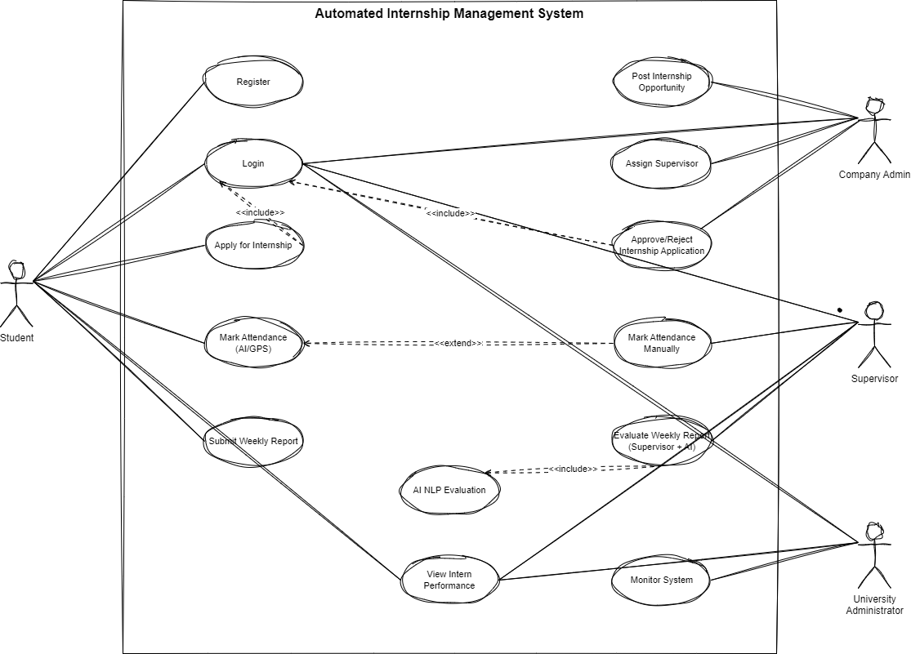
Figure 1Use case model diagram

      - Use case documentation
Table 5 use case description for login
Use case name | Login
Use Case ID | UC1
Actors | Student, Supervisor, Company Administrator, University Administrator
Description | The actor enters valid login credentials to access their respective . The system authenticates the credentials and redirects the user to the correct interface based on their role.
Pre- Conditions | - User must have a registered account  - User must know username and password
Post-conditions | - User is successfully authenticated  - User is redirected to their authorized dashboard
Basic Course of Action | User Action | System Response
 | - The user opens the system’s login page.  3 The user enters username and password.  5. The user clicks the “Login” button. | 2 The system displays the Login Interface.  4 The system validates the credentials.  6 If credentials are correct, system loads the appropriate dashboard (Student / Supervisor / Admin).  7 Use case ends
Alternate course of  action | User Action | System Response
 | A1. The user enters an incorrect username or password.  A3. The user tries again by reentering credentials.  A5. If multiple failed attempts occur. | A2. The system displays an “Invalid username or password” message.  A4. The system waits for new authentication attempt  A6. System may prompt CAPTCHA or lock account temporarily (security policy).
Table 6 use case description for Register
Use case name | Register
Use Case ID | UC2
Actors | Student, University Administrator
Description | This use case allows a student to register by submitting personal and academic details, which are approved by the University Administrator before login credentials are automatically issued.
Pre- Conditions | - Student must not already have an account  - Student must have a valid university ID  - Student has access to the system registration page
Post-conditions | - Student registration request is approved  - System-generated username and password are issued  - Student account is activated and ready for login
Basic Course of Action | User Action | System Response
 | 1 The student opens the registration request page.  3 The student enters required details.  5. The student clicks “Register.” | 2 The system displays the Registration Interface.  4 The system validates input fields for correctness and completeness.  6 System stores the request with Pending Approval status. And System notifies the University Administrator.  7 Administrator reviews and approves the registration.  9 System generates username and password.  10 System sends credentials to the student (email/system notification).
Alternate course of  action | User Action | System Response
 | A1. Student submits incomplete or invalid information.  A3. Student submits duplicate university ID.  A5. Administrator rejects the registration request. | A2. System displays validation error messages.  A4. System displays: “Student already registered.”  A6. System notifies the student of rejection with reason.
Table 7 use case description for Apply for Internship
Use case name | Apply for Internship
Use Case ID | UC3
Actors | Student
Description | This use case allows a student to browse available internship opportunities posted by approved organizations and submit an application through the system. Once submitted, the application is forwarded to the Company Admin for review and decision.
Pre- Conditions | - Student is successfully logged into the system  - Student has a complete profile
Post-conditions | - Internship application is submitted  - Company Admin receives the application for review
Basic Course of Action | User Action | System Response
 | 1 The student logs into the system.  3 Student selects “Apply for Internship.”  5. Student selects desired organization and submits application. | 2 System displays the student dashboard.  4 System displays list of approved organizations.  6 System records the application and forwards it to the assigned supervisor.  7 System shows confirmation message: “Application Submitted.”
Alternate course of  action | User Action | System Response
 | A1. Student tries to apply without completing profile.  A3. Student selects an organization that has reached capacity.  A5. Student corrects the issue and attempts to reapply. | A2. System displays: “Complete your profile before applying.”  A4. System displays: “This organization is no longer accepting interns.”  A6. System validates and submits the application.
Table 8 Approve/Reject Application
Use case name | Approve/Reject Application
Use Case ID | UC4
Actors | Company Admin
Description | This use case allows the Company Admin to review internship applications submitted by students and approve or reject them based on organizational criteria and internship capacity.
Pre- Conditions | - Company Admin must be logged into the system.  - Student must have submitted an internship application.
Post-conditions | - Application status is updated (Approved or Rejected)  - Student receives a status notification.
Basic Course of Action | User Action | System Response
 | 1,Company Admin logs into the system.  3, Company Admin selects “Review Applications.”  5, Company Admin opens an application and reviews student details.  7,Company Admin chooses either “Approve” or “Reject.” | 2, System displays the supervisor dashboard.  4, System displays a list of pending student applications.  6, System displays full application information.  8. System updates the application status and sends notification to the student.  9,Use case ends.
Alternate course of  action | User Action | System Response
 | A1. Company Admin attempts to review an already processed application.  A3. Company Admin tries to approve an incomplete application.  A5. Company Admin returns to the application list. | A2.System displays: “This application has already been reviewed.”  A4. System shows: “Missing information cannot approve.”  A6. System reloads pending applications.
Table 9 Mark Attendance
Use case name | Mark Attendance
Use Case ID | UC5
Actors | Student, Supervisor
Description | This use case enables students to mark daily attendance using AI-based face recognition and GPS verification. If automated verification fails, the system allows the student to request manual attendance approval, which is verified by the supervisor.
Pre- Conditions | - Student is logged into the system.  - Student device has camera and GPS enabled.  - Supervisor must be logged in to approve manual requests.
Post-conditions | - Attendance is recorded successfully.  - System updates attendance logs.
Basic Course of Action | User Action | System Response
 | 1,Student navigates to “Mark Attendance.”  3, Student captures face image.  5, Student confirms submission. | 2, System activates camera and GPS modules.  4, System performs facial recognition and GPS verification.  6, System records attendance if both checks succeed and displays “Attendance Marked Successfully.”
Alternate course of  action | User Action | System Response
 | A1. Face recognition fails or GPS is invalid.  A3.Student chooses “Request Manual Attendance.”  A5. Supervisor opens pending attendance requests.  A7. Supervisor approves or rejects the request. | A2.System displays: “AI/GPS Verification Failed.”  A4. System sends manual attendance request to the supervisor.  A6. System displays student details, GPS snapshot (if available), and timestamp.  A7. System updates attendance log and notifies the student (Approved/Rejected).

Table 10 Weekly Report Submission & Evaluation
Use case name | Weekly Report Submission & Evaluation (AI + Supervisor)
Use Case ID | UC6
Actors | Student, AI NLP Module, Supervisor
Description | This use case allows the student to submit a weekly report through the system. The system processes the report using an AI NLP model that analyzes clarity, content completeness, language structure, and relevance to assigned tasks. After the AI evaluation, the supervisor reviews both the report and AI score to give final approval and feedback.
Pre- Conditions | - Student is logged in  - Student has an active internship  - Supervisor is assigned to the student
Post-conditions | - Weekly report stored in system  - AI-generated evaluation score recorded  - Supervisor review completed and stored
Basic Course of Action | User Action | System Response
 | 1, Student selects “Submit Weekly Report.”  3, Student writes or uploads weekly report.  5, Student submits the report. | 2, System opens weekly report submission form.  4, System validates format and completeness.  6, System stores the report and sends it to the AI NLP module for analysis.
AI NLP Evaluation (System) | AI Action | System Response
 | 7, AI NLP analyzes grammar, task relevance, clarity, workload description, and completeness. | 8, System generates AI score and evaluation summary.  9, System forwards the report + AI analysis to the supervisor.
Supervisor Evaluation | User Action | System Response
 | 10, Supervisor opens “Weekly Reports” section  12, Supervisor reviews and edits score or adds comments. | 11, System displays student report + AI analysis + suggested score.  12, System saves final evaluation and updates student performance records.  13, Student is notified of the supervisor’s final feedback.

Sequence diagram
A sequence diagram illustrates the dynamic interaction between system components and actors by showing the order of messages exchanged during a specific process. It visually represents how users, system modules, and external components communicate over time. For the Automated Internship Management System, sequence diagrams demonstrate workflows such as Student Registration , internship application, attendance verification, and weekly report evaluation.
Figure 2 Sequence diagram for Student Registration
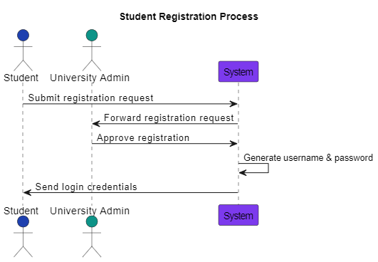

Figure 3 Sequence diagram Apply for internship
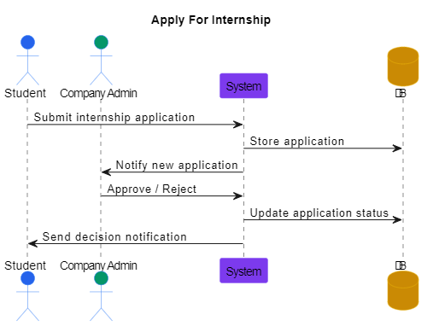

Figure 4 Sequence Diagram for Attendance
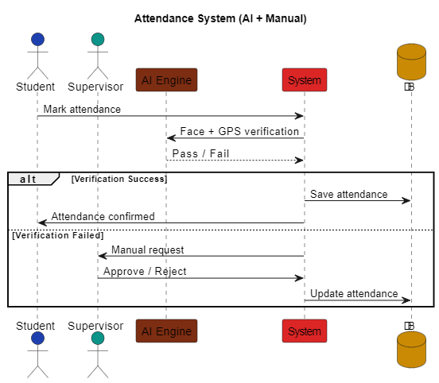
Figure 5 Weekly Report Evaluation
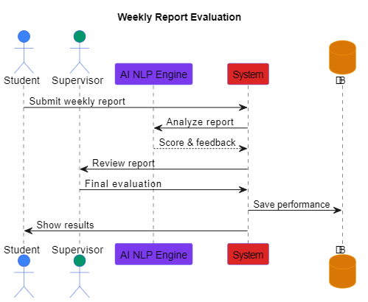

State chart diagram
A state chart diagram illustrates the different states an entity undergoes and the transitions triggered by events. In this system, it models changes such as application status, attendance state, and report evaluation progress, highlighting how the system responds to user actions.

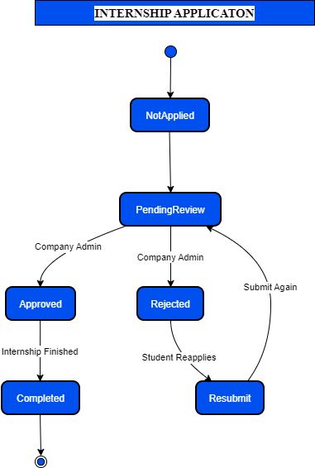
Figure 6 State chart diagram of Internship Application

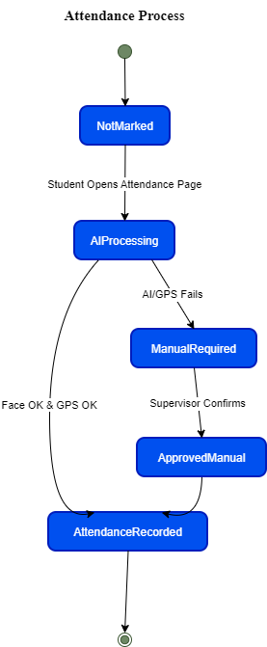
Figure 7 State Chart of Attendance Process

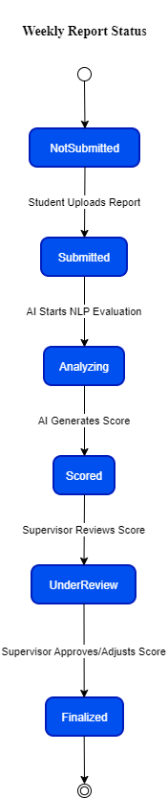
Figure 8 State chart of weekly report status

Activity Diagram
An activity diagram represents the workflow of processes within the system by illustrating sequential and parallel activities. It shows how tasks begin, flow, and end, including decision points and alternative paths. For the Automated Internship Management System, activity diagrams model procedures such as internship application, attendance marking, and weekly report submission, helping visualize system operations and user interactions clearly.
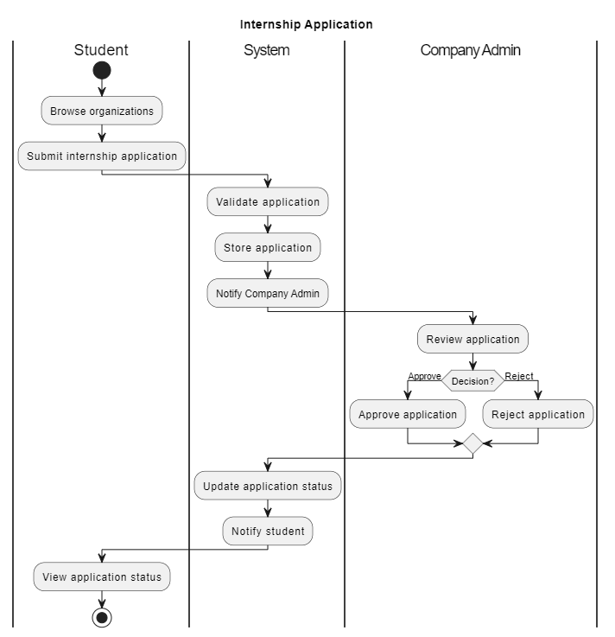
Figure 9 Activity Diagram of Internship Application
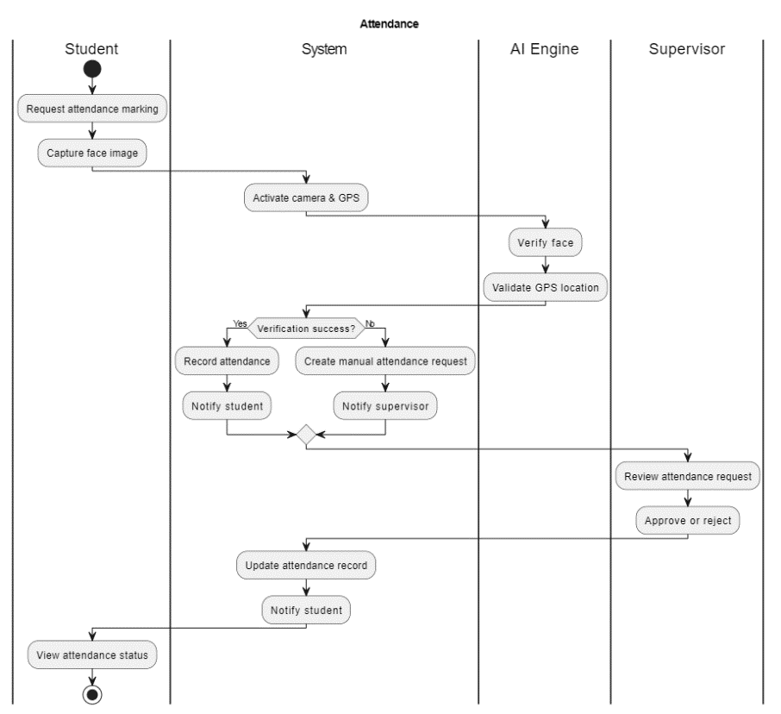
Figure 10 Activity Diagram of Attendance

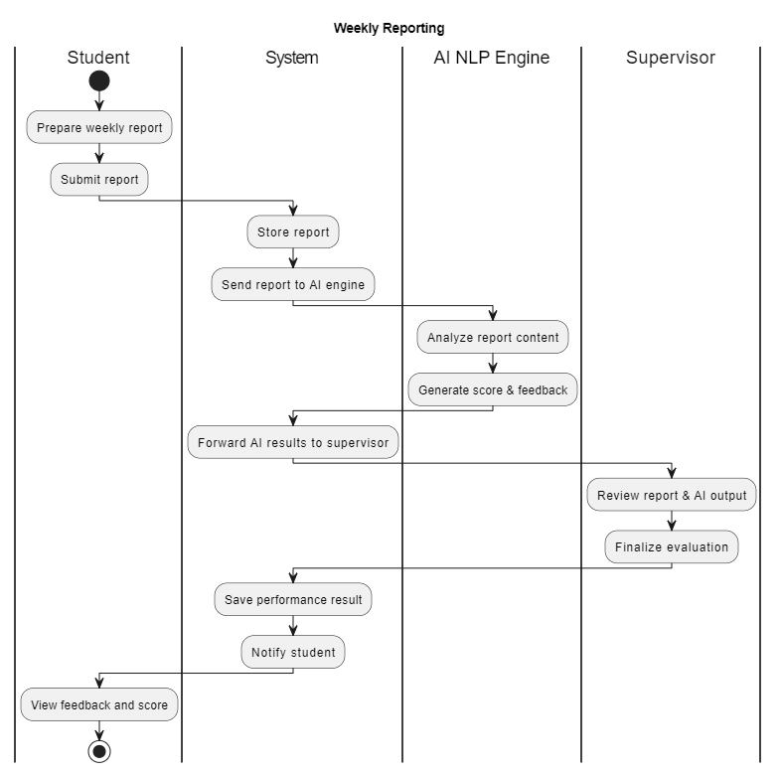
Figure 11 Activity diagram for Weekly Reporting

Class Diagram
A class diagram represents the system’s static structure by defining its classes, attributes, methods, and relationships. For the Automated Internship Management System, it shows entities such as Student, Supervisor, Attendance, Organization, and WeeklyReport, illustrating how these components interact to support core system functions.

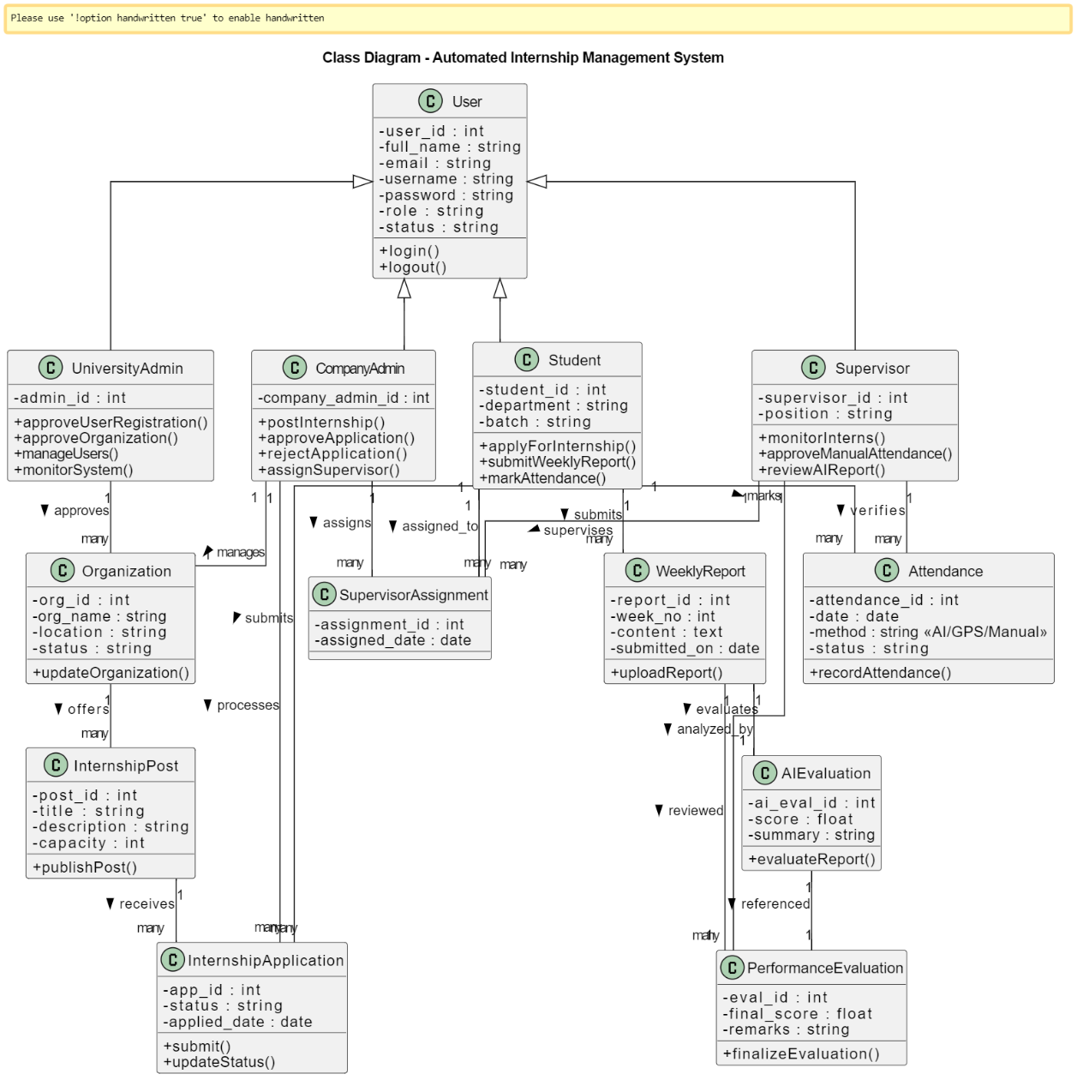
Figure 12 class diagram

User Interface Prototyping
Figure 13 Main flow
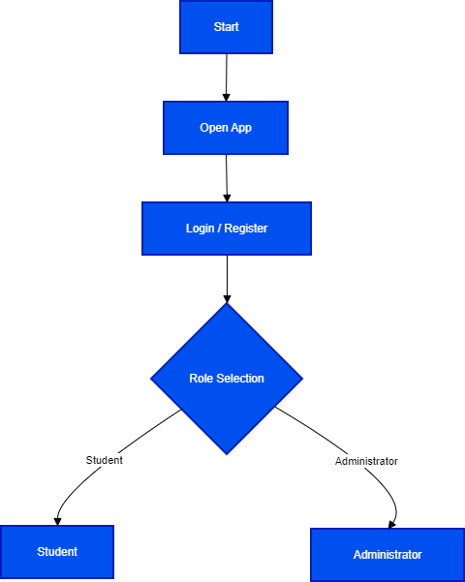

Figure 14 Student flow
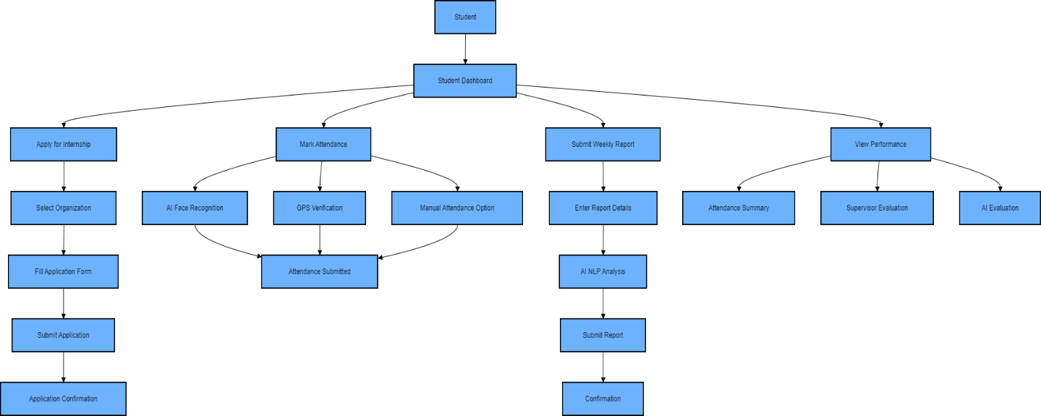

Figure 15 Supervisor flow
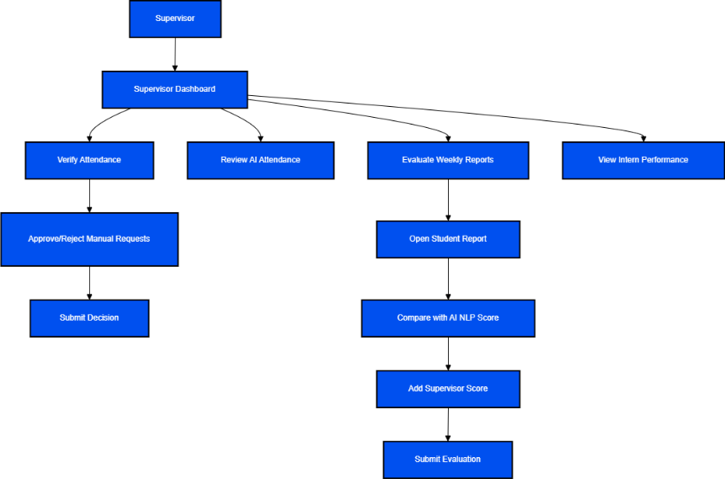
Figure 16 University Administrator
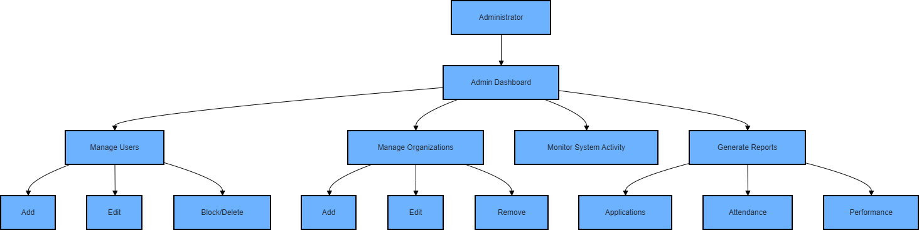
Figure 17 Company Admin
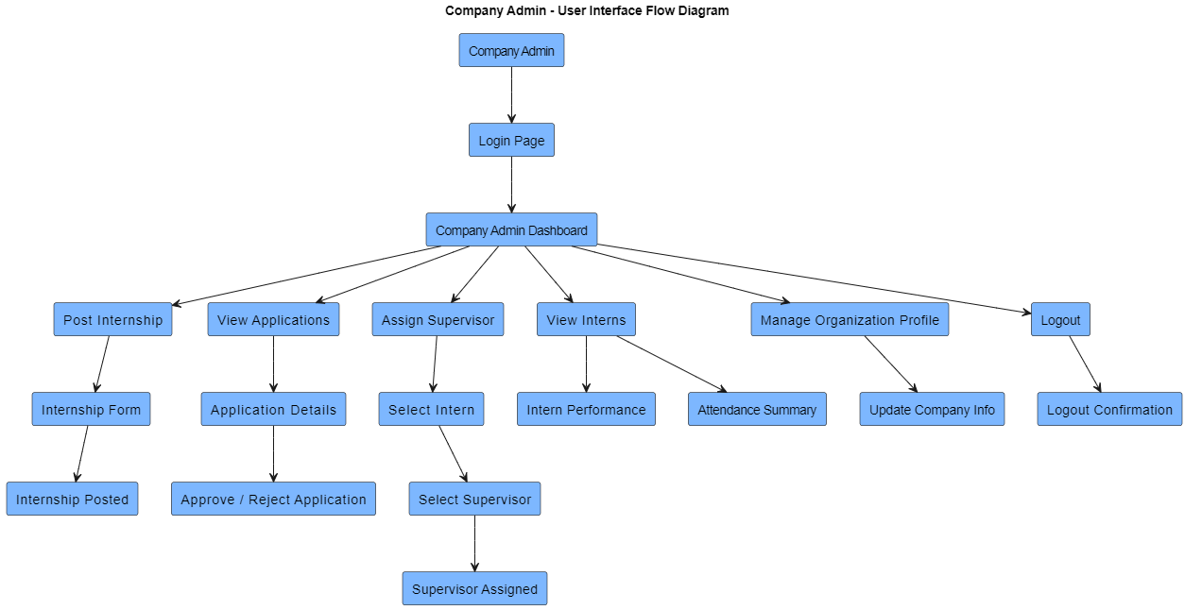

CHAPTER THREE

SYSTEM DESIGN

Introduction
This chapter presents the system design of the proposed Automated Internship Management System (AIMS), translating the system requirements into a detailed technical blueprint for implementation. System design defines how software components, hardware resources, databases, and artificial intelligence modules interact to achieve the intended objectives of the system. The chapter describes the overall architectural structure, deployment environment, subsystem decomposition, and data persistence mechanisms. It also explains access control strategies, global software control, and boundary conditions that govern system behavior. Special emphasis is placed on the integration of machine learning components, including face recognition for attendance verification, GPS-based location validation, and Natural Language Processing (NLP) for automated evaluation of weekly reports. The design prioritizes scalability, security, usability, and maintainability to ensure efficient support for students, company administrators, supervisors, and university administrators throughout the internship lifecycle.

Proposed System
The Automated Internship Management System is designed to modernize and automate the internship administration process through a centralized, AI-enabled web-based platform. The system reduces reliance on manual procedures, minimizes attendance manipulation, and improves transparency in performance evaluation. Students submit registration requests and apply for internships through the platform, while company administrators manage applications and assign supervisors. Attendance is recorded digitally using face recognition and GPS verification, ensuring accurate tracking of intern presence. Weekly reports are submitted online and analyzed using NLP-based models to generate objective performance insights, which are reviewed by supervisors. University administrators oversee system activities through centralized dashboards and generate institutional reports. By integrating artificial intelligence technologies, the system enhances accountability, operational efficiency, and data-driven decision-making, ultimately strengthening coordination between universities, host organizations, and students.

Design Goals
The design goals represent the desired qualities of the system and provide a consistent set of criteria that must be considered when making design decisions. Design goals of the system are presented as follows
- Modularity : The system is designed using a modular architecture where each subsystem (frontend, backend, database, and AI modules) operates independently while communicating through well-defined interfaces. This approach simplifies development, testing, maintenance, and future upgrades.
- Performance : The system ensures fast response time for attendance recording, report submission, and data retrieval. Optimized APIs, efficient database queries, and lightweight frontend components enhance overall performance even with multiple concurrent users.
- Robustness : The system is built to handle errors gracefully, including network failures, invalid inputs, and AI recognition issues. Alternative mechanisms such as manual attendance ensure continuity of operation.
- Flexibility : The architecture supports future expansion, such as adding new AI models, integrating mobile applications, or extending the system to other departments or universities.
- Compatibility : The system is web-based and compatible with modern browsers and devices. It integrates seamlessly with GPS-enabled devices, webcams, and existing university IT infrastructure.
- Reliability : Reliable data storage, regular backups, role-based access control, and secure authentication ensure consistent system operation and data integrity.

Deployment Diagram
Deployment diagram is a structure diagram which shows architecture of the system as deployment or distribution of software artifacts to deployment targets. Deployment diagrams model the physical architecture of a system. It also shows the relationship between the software and hardware. A deployment diagram shows how and where the system is to be deployed; that is, its execution architecture.
Figure 18 Deployment Diagram
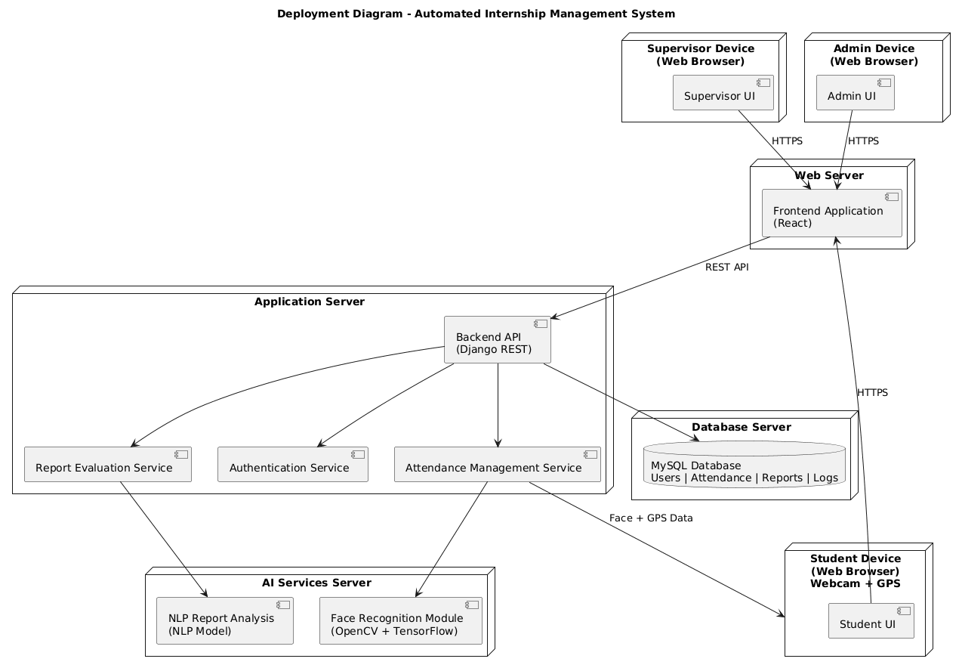

Architectural Design
The system’s architecture establishes a comprehensive structure that ensures conceptual integrity through a layered approach. The Automated Internship Management System is designed using a three-tier architecture, which separates user interaction, system logic, and data management concerns. This separation improves scalability, maintainability, security, and flexibility of the system.
- The Presentation Tier handles all user interactions and provides role-based graphical interfaces for students, company administrators, supervisors, and university administrators. It is responsible for capturing user inputs and displaying system responses through web-based dashboards.
- The Business Logic Tier acts as the core processing layer. It manages authentication, internship application processing, attendance verification, performance evaluation, and workflow coordination. This tier also integrates artificial intelligence components such as face recognition, GPS validation, and NLP-based report analysis.
- The Data Management Tier is responsible for storing, retrieving, and managing persistent system data. It maintains structured records related to users, internships, attendance, reports, and evaluations using a relational database. This tier ensures data integrity, consistency, and secure access across the system.
Figure 19 Architectural Design
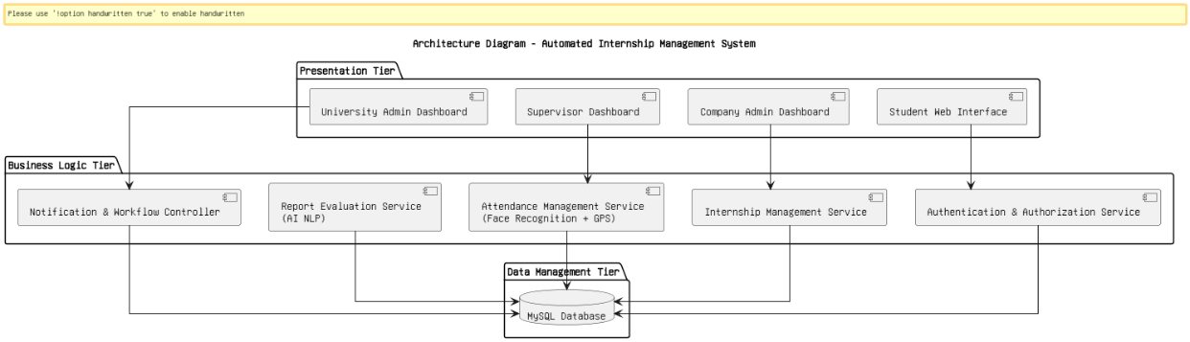
    - Subsystem Decomposition
The subsystem decomposition diagram breaks the Automated Internship Management System into smaller functional subsystems. Each subsystem handles a specific responsibility such as user management, internship processing, attendance verification, AI evaluation, and reporting. This decomposition improves system clarity, maintainability, and modular development.
Figure 20 Subsytem Decomposition
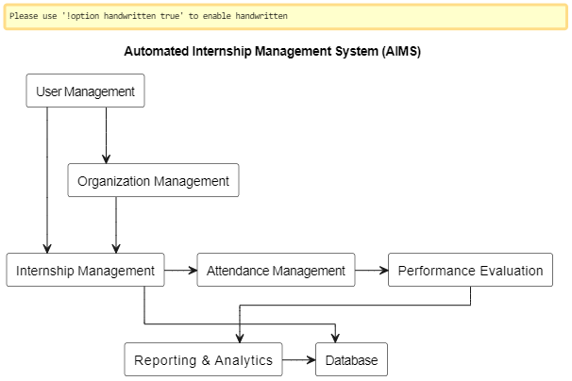

Component Diagram
The component diagram illustrates the logical organization of the Automated Internship Management System by showing how software components interact through defined interfaces. It identifies major components such as user authentication, internship management, attendance processing, AI evaluation, and reporting services. This diagram helps clarify component dependencies, promotes modular development, and supports system scalability and maintainability.
Figure 21 Component Diagram
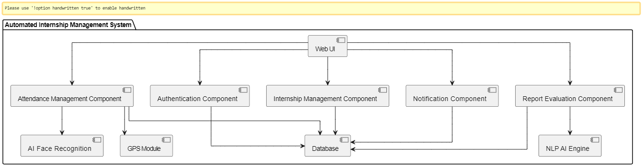
    - Deployment Diagram
The deployment diagram represents the physical deployment of the Automated Internship Management System across hardware and network environments. It shows how the web application, database server, and AI services are hosted and communicate over the internet. This diagram highlights system distribution, execution environment, and runtime communication between system components.
Figure 22 Deployment diagram 2
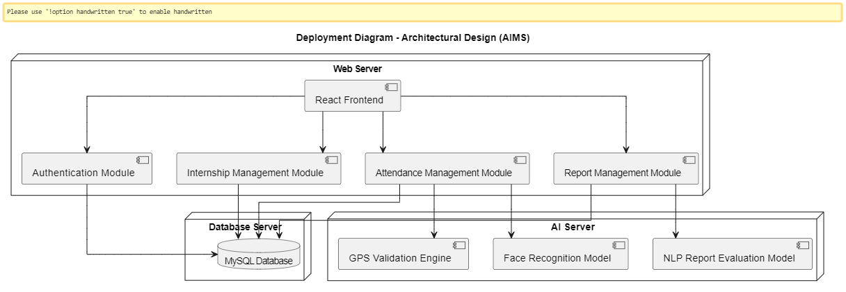

    - Persistent Modeling
Persistent modeling defines how system data is stored, managed, and retrieved to ensure long-term availability and consistency. In the Automated Internship Management System, all critical data such as user profiles, internship applications, attendance records, AI evaluation results, and performance reports are persistently stored in a centralized relational database. The system uses structured tables with defined relationships to maintain data integrity and avoid redundancy. Persistent storage ensures that data remains available across system sessions, supports auditing and reporting, and enables reliable recovery in case of system failure.
    - Access Control and Security
Access control and security mechanisms ensure that system resources are protected from unauthorized access. The system implements role-based access control (RBAC), where permissions are assigned according to user roles such as student, company administrator, supervisor, and university administrator. Secure authentication using encrypted credentials prevents unauthorized login attempts. Sensitive data such as attendance records and performance evaluations are protected through authorization checks and secure communication channels. Activity logging further enhances accountability and supports auditing
    - Global Software Control
Global software control defines how the system manages execution flow and coordination among its components. The Automated Internship Management System follows a centralized control model where the application server coordinates user requests, business logic execution, AI processing, and database transactions. System controllers handle event sequencing, error handling, and workflow transitions such as application approval, attendance submission, and report evaluation. This centralized control ensures consistent system behavior and reliable execution of critical processes.

    - Boundary Conditions
Boundary conditions describe how the system behaves at startup, shutdown, and during exceptional situations. When the system starts, all services such as authentication, database connections, and AI modules are initialized. During operation, the system handles errors such as invalid inputs, network failures, or AI verification issues by providing meaningful feedback to users. At shutdown, active sessions are safely terminated and pending data is stored to prevent data loss. These boundary controls ensure system stability and data consistency.
    - Machine Learning Model Design
The system integrates machine learning models to enhance automation and accuracy. Face recognition models are used to verify student identity during attendance submission, while GPS validation ensures physical presence at the organization’s location. Additionally, an NLP-based model analyzes weekly reports to assess relevance, completeness, and quality. These models operate as independent services within the system and interact with the core application through defined interfaces. Their modular design allows continuous improvement and retraining without affecting overall system operation.

User Interface Design
Figure 23 Landing page
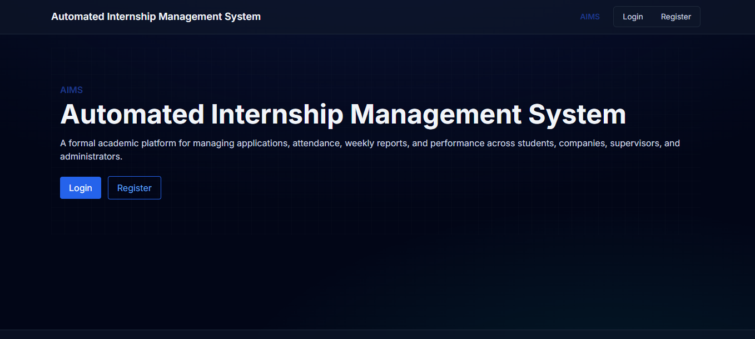
Figure 24 Login Page
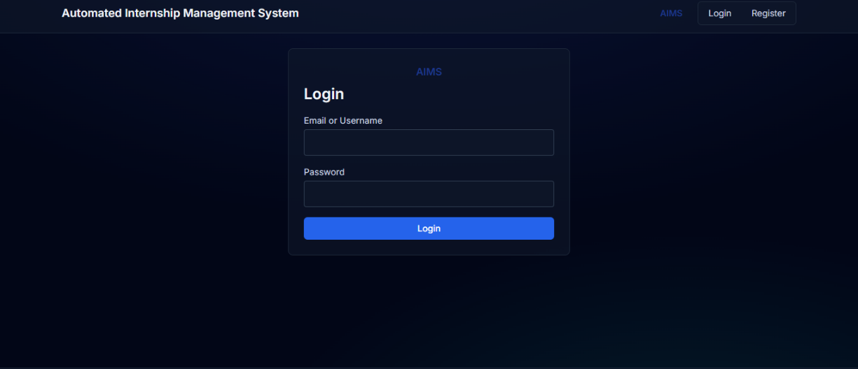
Figure 25 Register Page
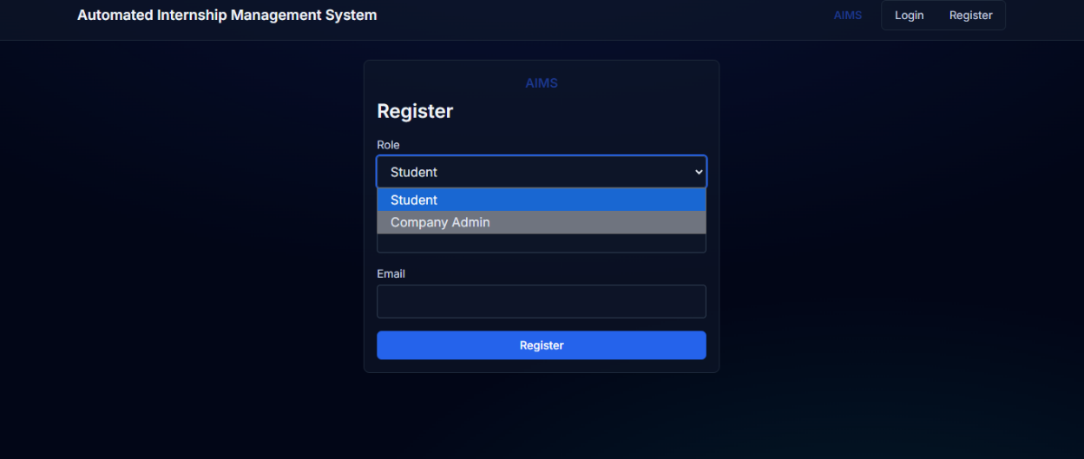
Figure 26 Student Page
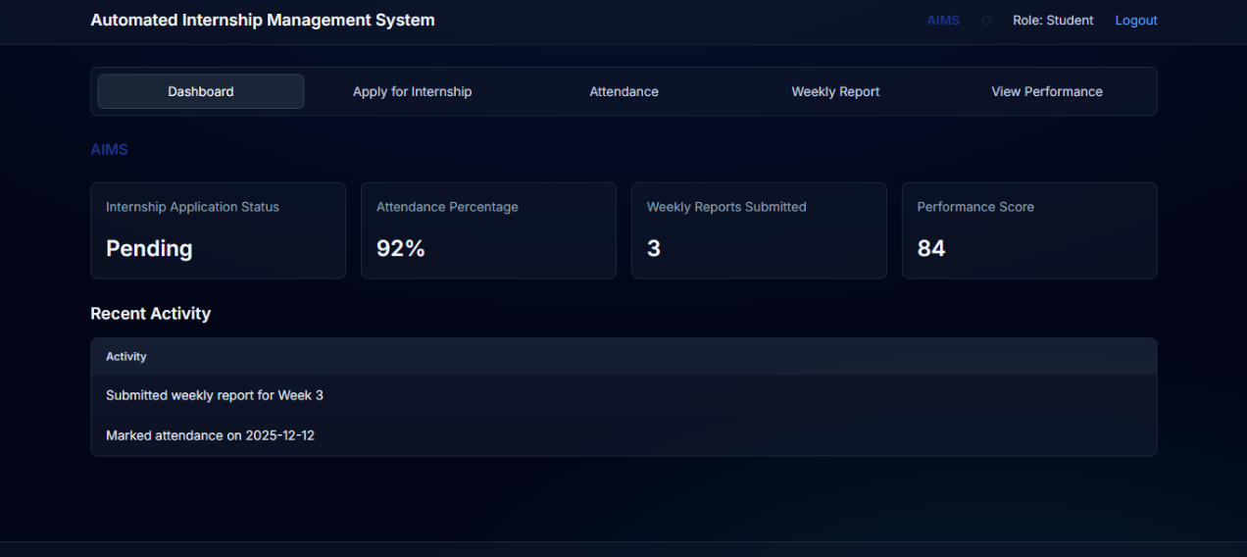
Figure 27 University Admin
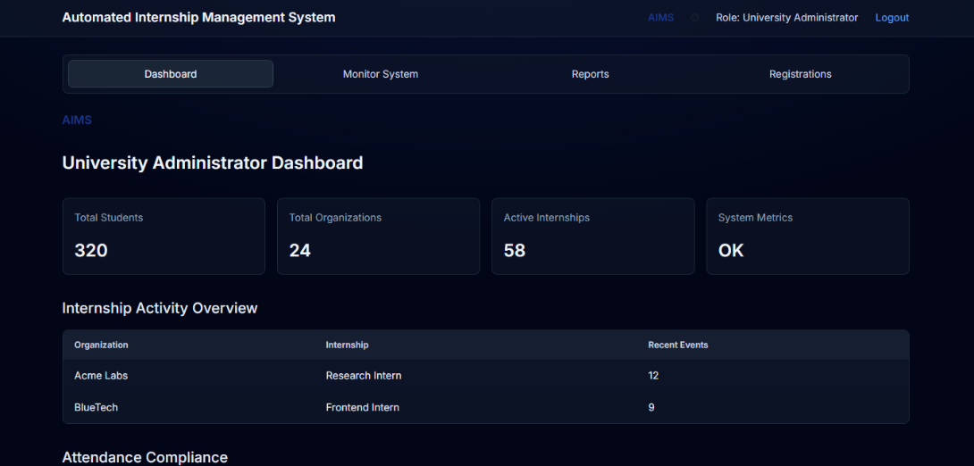
Figure 28 Company Admin
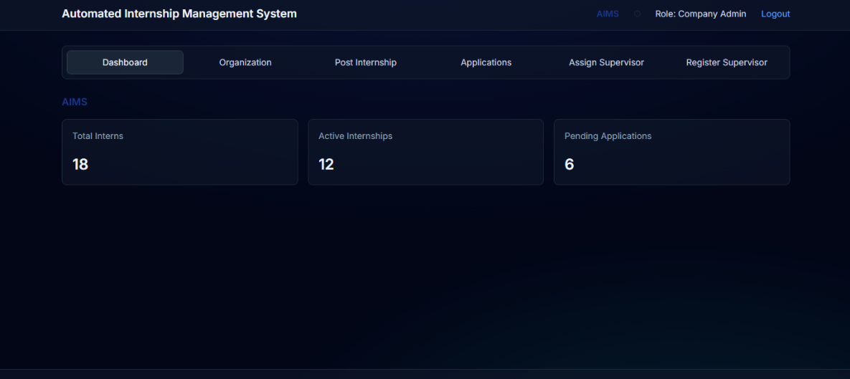
Figure 29 Supervisor page
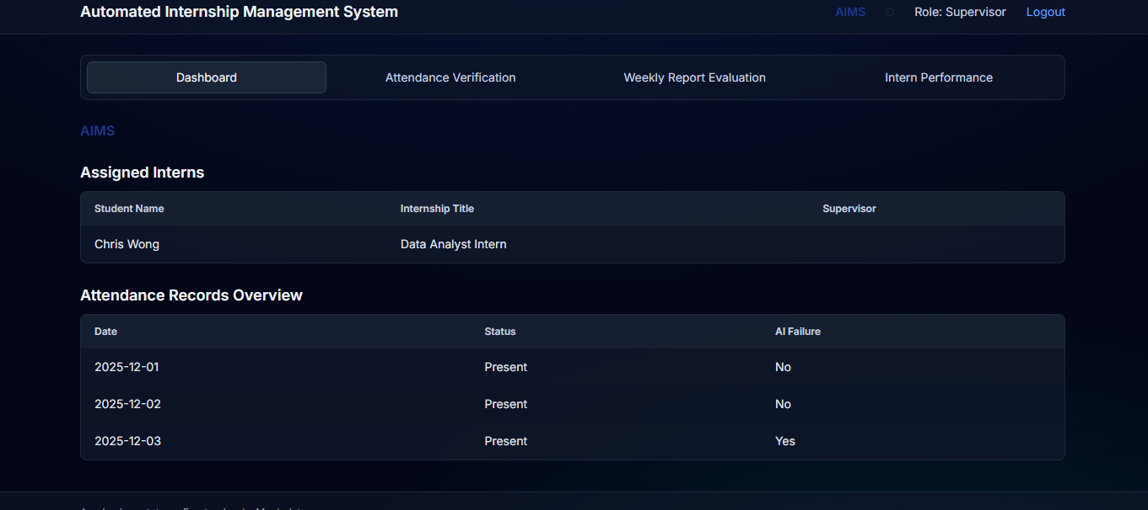
  - Database Design
The database design of the Automated Internship Management System (AIMS) provides a structured and reliable way to store, manage, and retrieve system data. A relational database model is used to ensure data integrity, consistency, and efficient querying. The database supports all core system functions including user management, internship applications, attendance tracking, AI evaluation results, and performance reporting. Relationships between tables are clearly defined using primary and foreign keys to avoid redundancy and ensure referential integrity.
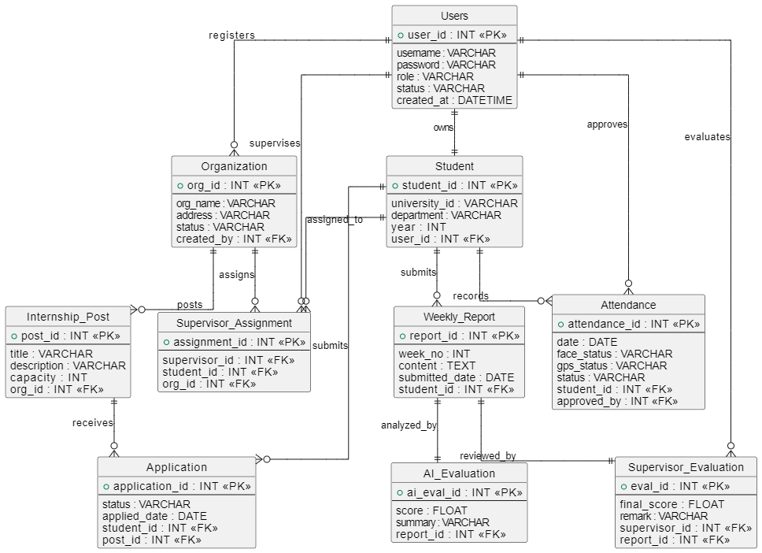
Figure 30 ER DIAGRAM
Table 11 Users Table
Column name | Data type | Primary key | Foreign key | Nullable | Uniqueness
user_id | Integer | ✓ |  | No | ✓
username | Varchar(255) |  |  | No | ✓
password | Varchar(255) |  |  | No
role | Varchar(50) |  |  | No
status | Varchar(50) |  |  | No
created_at | DateTime |  |  | No
Table 12 Students
Column name | Data type | Primary key | Foreign key | Nullable | Uniqueness
student_id | Integer | ✓ |  | No | ✓
user_id | Integer |  | Users(user_id) | No | ✓
university_id | Varchar(255) |  |  | No | ✓
department | Varchar(255) |  |  | No
year | Integer |  |  | No
Table 13 Organization
Column name | Data type | Primary key | Foreign key | Nullable | Uniqueness
org_id | Integer | ✓ |  | No | ✓
org_name | Varchar(255) |  |  | No | ✓
address | Varchar(255) |  |  | No
status | Varchar(50) |  |  | No
created_by | Integer |  | Users(user_id) | No
Table 14 Internship_Post
Column name | Data type | Primary key | Foreign key | Nullable | Uniqueness
post_id | Integer | ✓ |  | No | ✓
org_id | Integer |  | Organization(org_id) | No
title | Varchar(255) |  |  | No
description | Varchar(255) |  |  | No
capacity | Integer |  |  | No
Table 15 Applications
Column name | Data type | Primary key | Foreign key | Nullable | Uniqueness
application_id | Integer | ✓ |  | No | ✓
student_id | Integer |  | Student(student_id) | No
post_id | Integer |  | Internship_Post(post_id) | No
status | Varchar(50) |  |  | No
applied_date | Date |  |  | No

Table 16 Supervisor_Assignment
Column name | Data type | Primary key | Foreign key | Nullable | Uniqueness
assignment_id | Integer | ✓ |  | No | ✓
supervisor_id | Integer |  | Users(user_id) | No
student_id | Integer |  | Student(student_id) | No
org_id | Integer |  | Organization(org_id) | No
Table 17 Attendance
Column name | Data type | Primary key | Foreign key | Nullable | Uniqueness
attendance_id | Integer | ✓ |  | No | ✓
student_id | Integer |  | Student(student_id) | No
date | Date |  |  | No
face_status | Varchar(50) |  |  | No
gps_status | Varchar(50) |  |  | No
approved_by | Integer |  | Users(user_id) | Yes
status | Varchar(50) |  |  | No

Column name | Data type | Primary key | Foreign key | Nullable | Uniqueness
report_id | Integer | ✓ |  | No | ✓
student_id | Integer |  | Student(student_id) | No
week_no | Integer |  |  | No
content | Varchar(255) |  |  | No
submitted_date | Date |  |  | No
Table 18 Weekly_Report

Table 19 AI_Evaluation
Column name | Data type | Primary key | Foreign key | Nullable | Uniqueness
ai_eval_id | Integer | ✓ |  | No | ✓
report_id | Integer |  | Weekly_Report(report_id) | No | ✓
score | Float |  |  | No
summary | Varchar(255) |  |  | No
Table 20 Supervisor_Evaluation
Column name | Data type | Primary key | Foreign key | Nullable | Uniqueness
eval_id | Integer | ✓ |  | No | ✓
report_id | Integer |  | Weekly_Report(report_id) | No | ✓
supervisor_id | Integer |  | Users(user_id) | No
final_score | Float |  |  | No
remark | Varchar(255) |  |  | Yes

Summary
This chapter presented a comprehensive system design for the Automated Internship Management System, transforming the identified functional and non-functional requirements into a clear and structured technical blueprint. It detailed the overall system architecture, including the layered design approach, deployment environment, subsystem decomposition, component interactions, and database design. The chapter also explained access control and security mechanisms, global software control, boundary conditions, and persistent data management strategies that ensure reliable system operation.
Special emphasis was placed on the integration of intelligent components such as AI-based face recognition, GPS-based attendance verification, and NLP-driven weekly report evaluation, which collectively enhance accuracy, transparency, and fairness in internship monitoring.
Final Year Project I primarily focused on requirement analysis and system design. In the next phases, the project will progress to full system implementation, machine learning model training and optimization, comprehensive testing, deployment, and performance evaluation. Future work will also explore system enhancements such as mobile application support, advanced analytics, and improved user experience based on stakeholder feedback.

REFERENCE
- Nurfaizi, K., & Hindarto, D. (2023). Web-based student internship attendance application system for effective student attendance monitoring. International Journal of Software Engineering and Computer Science, 5(2), 45–52.
- Manual Internship Systems in Educational Contexts. (2021). Challenges of manual internship administration in higher education institutions. Journal of Educational Management and Information Systems, 9(1), 33–41.

